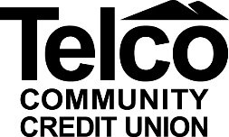

PROCEDURE FOR CAR LOAN DEFERMENT
Deferment Requests: When a member requests to defer a payment on their loan due to medical reasons, out of work, etc., they must submit in writing the reason for the deferment and mail to
Telco Community Credit Union
ATTN: Telco Underwriting Department
CLO/Loan Committee
1137 Smokey Park Highway
Candler, NC 28715
Along with the Deferment Request form, the Member Service Representative will complete an appraisal of the vehicle, pull an updated NADA value, and complete a Loan Subsequent Action for the deferment, signed by the member.
Note: Members will be charged $35 for each deferment request.

